IBM Assignment - 4

**QUESTION**

**Write code and connections in wokwi for ultrasonic sensor. Whenever distance is less than 100 cms send "alert" to IBM cloud and display in device recent events. Upload document with wokwishare link and images of IBM cloud.**

**SUDHARSHINI V**

**CODE :**

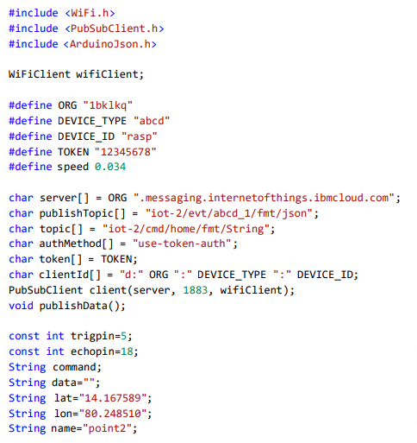

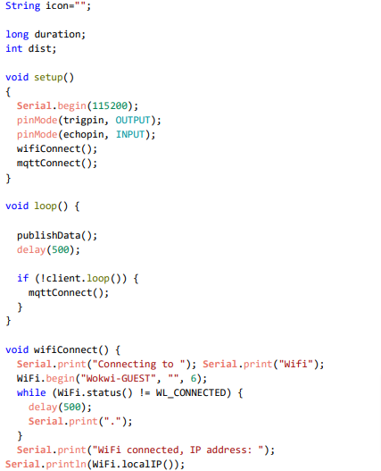

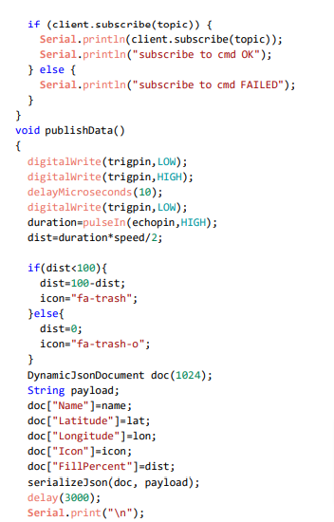

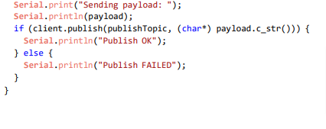

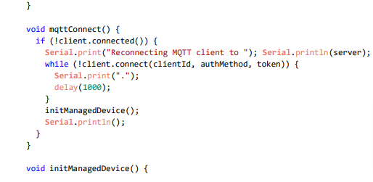

**Connections:**

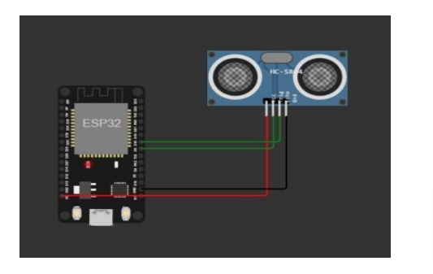

WOKWI LINK:

**https://wokwi.com/projects/346587874175484499**

OUTPUT:

